### **Report for Restaurant Analysis of Swiggy**

## 

**Project Title**: Swiggy Restaurant Analysis Using Power BI  
**Author**: Pooja Kamate  
**Batch**: MB-26  
**Course**: BADM

**Table of Contents**

1. **Executive Summary**
2. **Introduction**
3. **Data Source and Preparation**
4. **Task Analysis and Findings**
   * Task 1: Top 10 Areas with Most Restaurants
   * Task 2: Most Popular Food Types Served by Swiggy Restaurants in Each City
   * Task 3: Top Rated Swiggy Restaurants (In Percentage)
   * Task 4: Correlation of Factors Affecting Average Rating
   * Task 5: Correlation Between Restaurant Price and Average Rating
   * Task 6: City-wise Restaurant Count
   * Task 7: Price Analysis
   * Task 8: Delivery Time Analysis
   * Task 9: Cuisine Analysis
   * Task 10: Area-wise Restaurant Analysis
   * Task 11: Correlation Analysis
   * Task 12: Customer Feedback Analysis
   * Task 13: Geographical Mapping
5. **Conclusion**
6. **Business Recommendations**
7. **Appendices**
8. **References**

## **Executive Summary**



This report delves into Swiggy's restaurant data using Power BI, focusing on identifying key restaurant concentrations, analysing popular cuisines, examining factors influencing ratings, and offering actionable business recommendations. The insights gathered aim to enhance service quality and operational efficiency, guiding strategic decisions for Swiggy.

## **Introduction**



### **Background**

Swiggy is a leading food delivery platform in India, connecting customers with a diverse range of restaurants. Understanding the performance and characteristics of these restaurants is crucial for improving service quality and customer satisfaction.

### **Objectives**

This analysis aims to:

* Identify primary locations with the highest restaurant concentrations.
* Determine popular food types across different cities.
* Analyse factors affecting restaurant ratings.
* Provide strategic recommendations based on the findings.

### **Scope**

The analysis covers various dimensions including restaurant locations, cuisine types, pricing, ratings, delivery times, and customer feedback across multiple cities.

### **Tools and Technologies**

Power BI was utilized for data visualization and analysis, complemented by Excel for initial data processing and exploration.

## **Task Analysis and Findings**



### **Task 1: Top 10 Areas with Most Restaurants**

#### **Objective**

Identify the top 10 areas with the highest number of restaurants.

#### **Findings**

The top 10 areas predominantly include bustling urban neighborhoods renowned for their vibrant dining scenes.

#### 

#### **Visual Example**

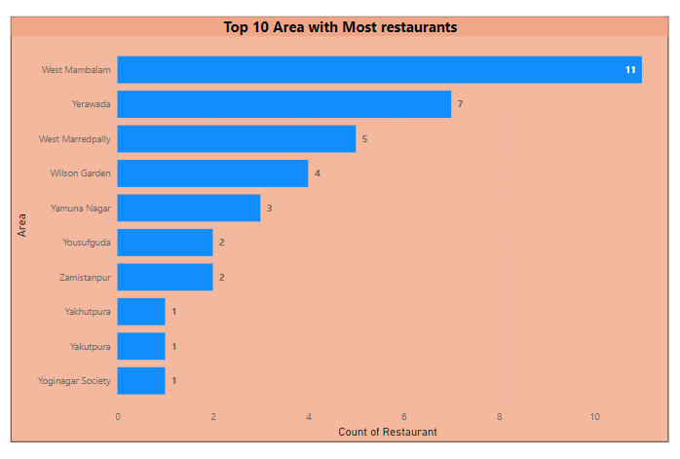

### **Task 2: Most Popular Food Types Served by Swiggy Restaurants in Each City**

#### **Objective**

Determine the most popular food types served in each city.

#### **Findings**

Distinct popular cuisines exist in each city, reflecting local preferences and cultural influences.

**Visual Example**

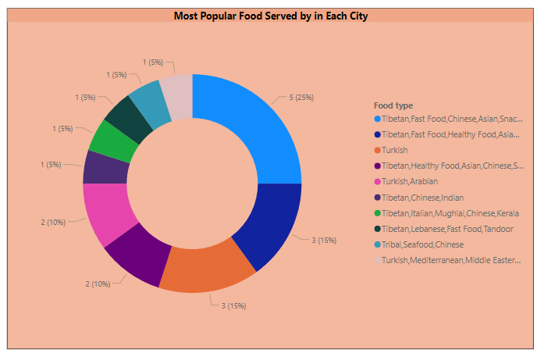

### 

### **Task 3: Top Rated Swiggy Restaurants (In Percentage)**

#### **Objective**

Determine the percentage of top-rated restaurants with an average rating above 4.5.

#### **Findings**

A significant proportion of restaurants achieve high ratings, indicating strong customer satisfaction.

#### **Visual Example**

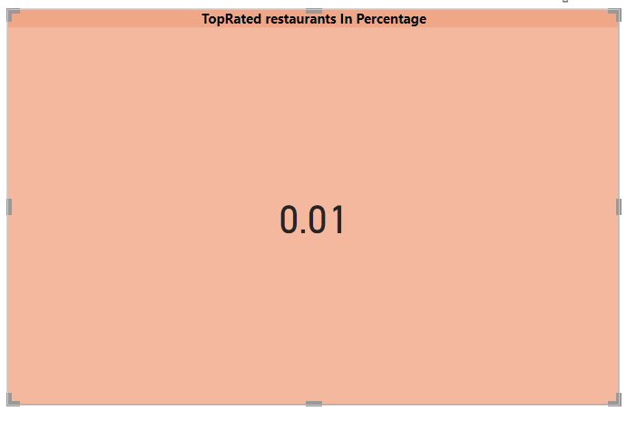

### 

### **Task 4: Correlation of Factors Affecting Average Rating**

#### **Objective**

Identify correlations between factors such as price, total ratings, and delivery time with average rating.

#### **Findings**

Price and total ratings exhibit notable correlations with average ratings, while delivery time shows less impact

#### **Visual Example**

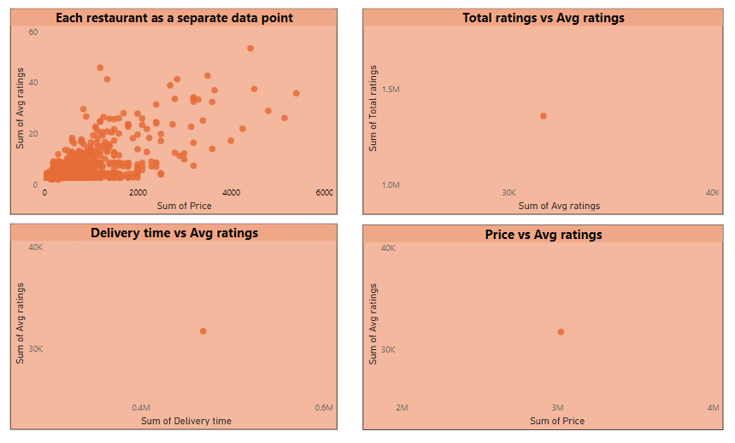

### 

### **Task 5: Correlation Between Restaurant Price and Average Rating**

#### **Objective**

Analyze the relationship between restaurant price and average rating.

#### **Findings**

Higher-priced restaurants generally tend to have higher ratings, although exceptions exist.

#### **Visual Example**

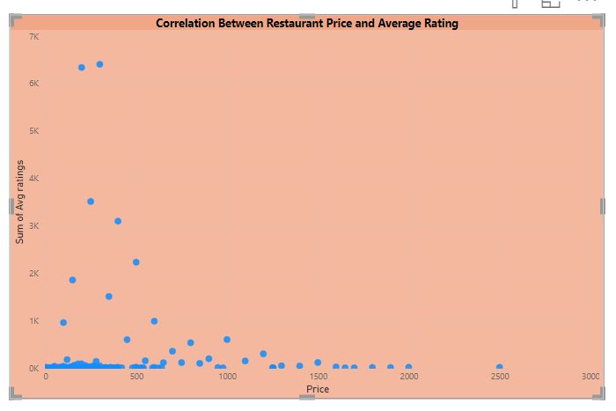

### 

### **Task 6: City-wise Restaurant Count**

#### **Objective**

Determine the number of restaurants in each city.

#### **Findings**

Cities with larger populations or well-established food cultures typically have higher restaurant densities.

#### **Visual Example**

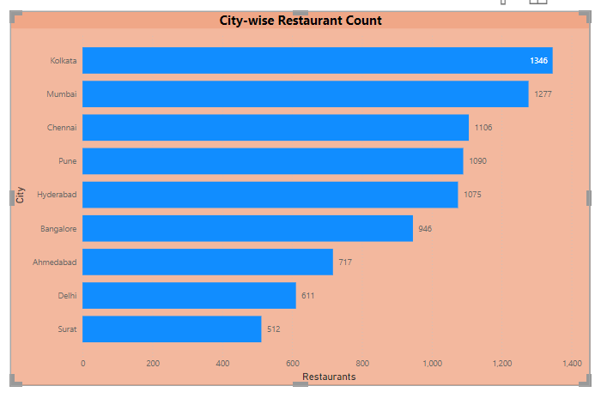

### 

### **Task 7: Price Analysis**

#### **Objective**

Analyze the distribution of restaurant pricing.

#### **Findings**

Most restaurants are moderately priced, with a few high-end outliers affecting average pricing.

#### **Visual Example**

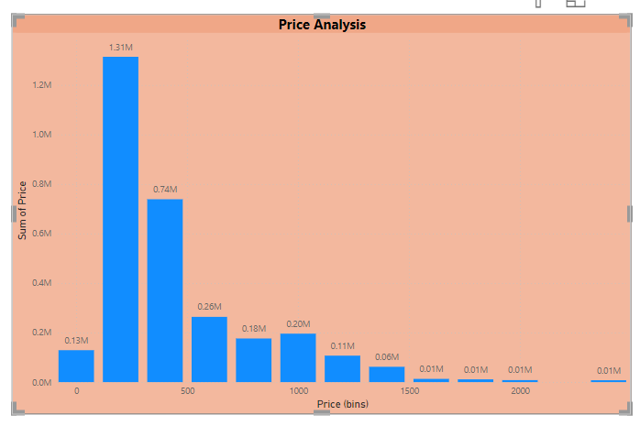

### 

### **Task 8: Delivery Time Analysis**

#### **Objective**

Analyze the average delivery times of restaurants.

#### **Findings**

Delivery times vary across locations, influenced by factors like traffic and distance.

#### **Visual Example**

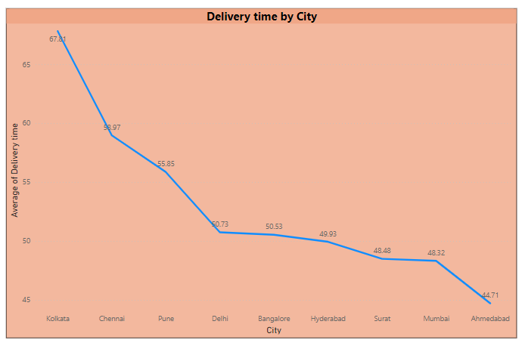

### 

### **Task 9: Cuisine Analysis**

#### **Objective**

Analyze the diversity of cuisines offered by restaurants.

#### **Findings**

Indian cuisine dominates, but there is significant diversity in offered food types.

#### **Visual Example**

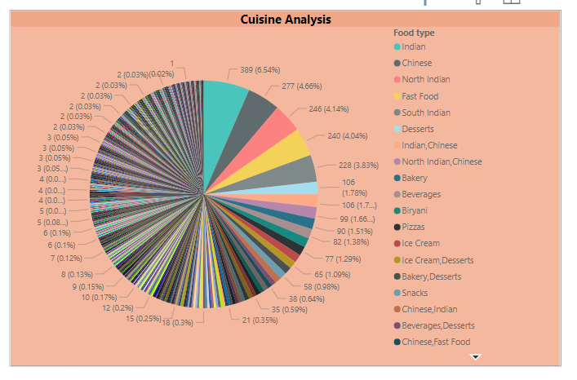

### 

### **Task 10: Area-wise Restaurant Analysis**

#### **Objective**

Analyze restaurant distribution within city areas.

#### **Findings**

Certain areas emerge as major food hubs with high concentrations of restaurants.

#### **Visual Example**

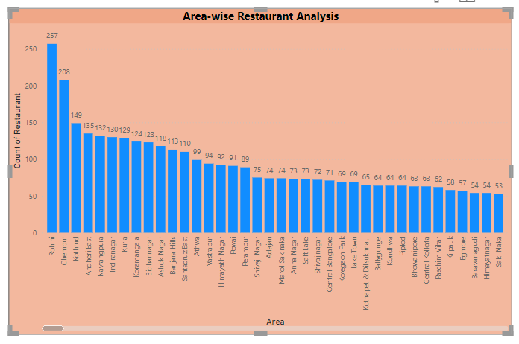

### 

### **Task 11: Correlation Analysis**

#### **Objective**

Investigate correlations between variables such as price, ratings, and delivery time.

#### **Findings**

Notable correlations exist, particularly between price and ratings, influencing customer satisfaction.

#### **Visual Example**

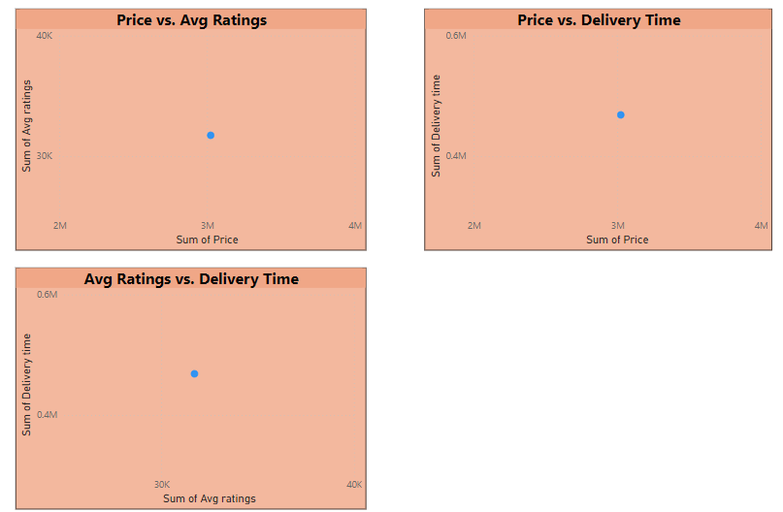

### 

### **Task 12: Customer Feedback Analysis**

#### **Objective**

Analyze customer feedback based on ratings and total reviews.

#### **Findings**

Positive feedback is prevalent, highlighting areas for service and quality improvement.

#### **Visual Example**

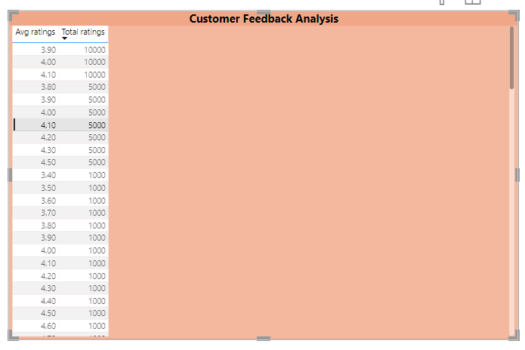

### 

### **Task 13: Geographical Mapping**

#### **Objective**

Create a geographical map of restaurant locations.

#### **Findings**

Restaurant locations align with urban population centers and business districts.

#### **Visual Example**

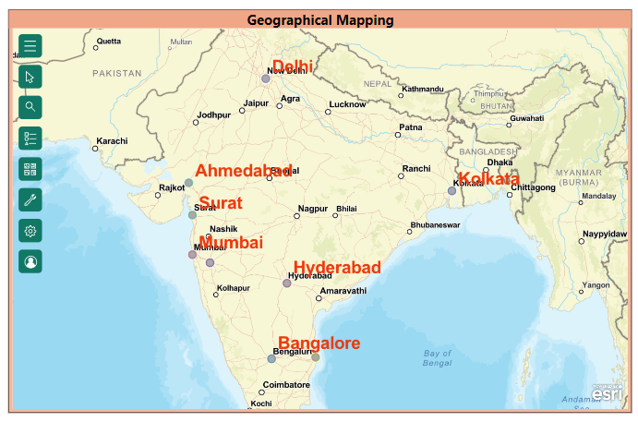

## **Conclusion**



### **Summary**

This analysis provides valuable insights into Swiggy's restaurant data, including restaurant density, popular cuisines, and factors influencing ratings. These insights can guide Swiggy in optimizing its service offerings and operational strategies.

### **Implications**

The findings suggest opportunities for Swiggy to expand in high-demand areas, promote popular cuisines, and enhance customer satisfaction by addressing pricing and delivery time issue.

### **Future Work**

Future analyses could include deeper sentiment analysis of customer reviews, more detailed geographical analyses, and integration of additional data sources for comprehensive insights.

**Business Recommendations**



### **Actionable Insights**

1. **Expand in High-Demand Areas**: Focus on expanding services in areas with high restaurant density and customer demand.
2. **Promote Popular Cuisines**: Utilize insights on popular food types to enhance marketing strategies.
3. **Optimize Pricing**: Align pricing strategies with customer expectations and restaurant quality.
4. **Improve Delivery Efficiency**: Address delivery time challenges to enhance overall customer satisfaction.

### **Strategic Decisions**

1. **New Market Exploration**: Identify new market opportunities based on geographical analysis.
2. **Customer Satisfaction Initiatives**: Implement targeted initiatives to improve service quality and reduce delivery times.

## **Appendices**



### **Detailed Data Tables**

Include supporting data tables that were essential for analysis but not included in the main report.

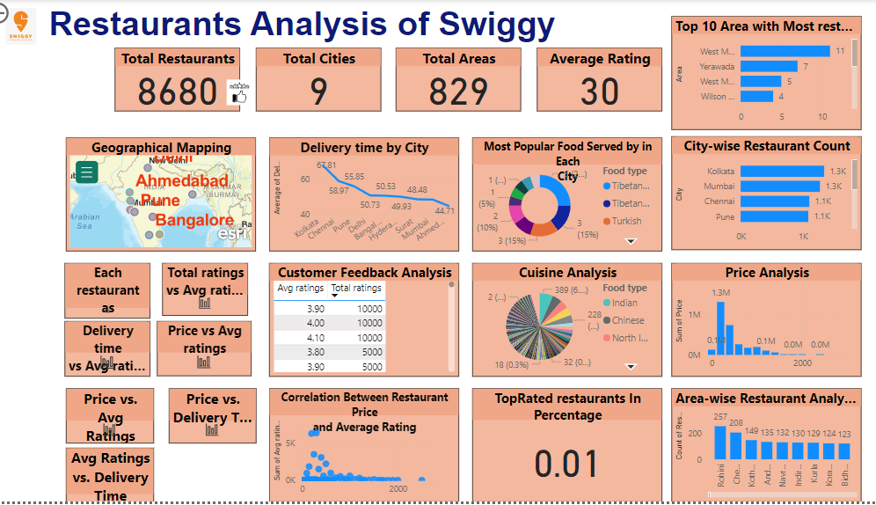

### **Additional Visualizations**

Provide supplementary charts or dashboards that offer further insights into the data.



**Code Snippets**

Include significant DAX formulas or scripts used in Power BI for data analysis.

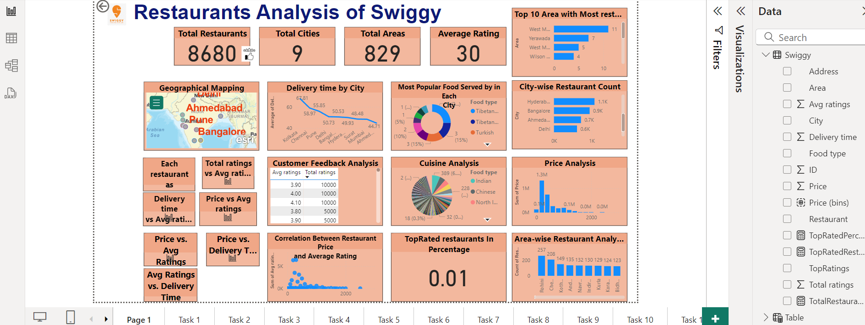

## **References**

### **Data Sources**

List all data sources used in the analysis.

### **Methodologies and Tools**

Outline the methodologies employed, emphasizing the use of Power BI for visualization and data analysis.

**Thank You**